**Oyster Task Force Minutes**

**Tuesday, July 23, 2024, 10:00am**

**New Orleans Lakefront Airport**

**6001 Stars and Stripes Blvd.**

**New Orleans, LA 70126**

**I.** Pledge of Allegiance

**II.** Roll Call and introduction of guests

**Voting Members Present:**

Dan Coulon

Jakov Jurisic

Mitch Jurisich

Brad Robin

Brandt Lafrance

Al Sunseri

Willie Daisy

**Voting Members Absent:**

Shane Bagala

Tracy Collins

Brandon Debarge

Matthew Slavich

Sam Slavich

Peter Vujnovich

Steve Pollock

**Non-Voting Member Present:**

Robert Caballero

Brian Lezina

**Non-Voting Members Absent:**

Edward Skena

Kyle Balkum

**III.** Brad Robin motioned to approve the June 12, 2024 meeting minutes, 2nd by Brandt Lafrance. Motion carries.

Jakov Jurisic motioned to add an item under New Business, A-2, To Consider Funding for the Oyster Day on the Bay Breakfast, 2nd by Al Sunseri. Motion carries.

Jakov Jurisic motioned to accept the agenda as amended, 2nd by Brad Robin. Motion carries.

**IV.** Treasury Report

Remaining Fund Balance- $584,254

Remaining Budget Balance- $13,735

Brad Robin motioned to approve the treasury report as presented, 2nd by Willie Daisy. Motion carries.

**V.** Committee reports

1. Public-Private Oyster Seed Grounds Committee Report- No report
2. Enforcement Report

June 6 – July 17

**Region 4** (Iberia)

Iberia

1-RS 40:4 A – Violate Sanitation Code – (refrigeration)

**Seizures-** 3 Sacks

**Region 5** (Calcasieu, Cameron, Vermillion)

NONE

**Region 6**: (Terrebonne, Lafourche, Grand Isle)

NONE

**Region 8**: (Jefferson, Plaquemines, St. Bernard, Orleans)

Plaquemines

1-RS 40:4 A – Violate Sanitation Code – (refrigeration)

**Seizures:** 14 Sacks

1. Legislative Committee- No report
2. Legal Committee- No report
3. Research Committee- Earl Melancon stated that the USDA- Risk Management is working with Sea Grant to develop a crop insurance program for the traditional oyster industry; Brad Robin discussed trip to private leases with USDA, Sea Grant, LDWF- demonstrated cultch planting, spoke about the hazards/ issues of the industry, insurance coverage should protect against freshwater events, hurricanes, and chemical spills

Al Sunseri stated that Buddy Pausina and Mike Voisin worked with the FDA on a program, worked on this for a while to develop crop insurance for the oyster industry, may be able to add to the work they have already done

Brad Robin provided an update on the Oyster Day on the Bay, stated that the main goal was to show USDA what the oyster industry does in terms of farming for their crop, the issue is in between the time of planting cultch there are disasters that can happen between planting and dredging up the oyster, showed the process of catching oysters all the way to eating them, showed them reefs and coast and crop, two and three years out, showed them unloading oysters and refrigeration the end result we showed them how to eat them, the group was out there from 7am-4:30/5pm and think they left with a clear mind that oystermen are farmers on the water, explained that need for coverage for freshwater events, hurricanes and some chemical spills

Earl Melancon stated that Claire White out of Kansas City will be the industry’s insurance contact, Brook Stuart based out of Jackson, MS was also present on the trip, all 8 individuals were blown away by the Day on the Bay, putting together a presentation on what is available now and what may be available in the future to the industry in regards to insurance to be presented at a future meeting

1. Coastal Restoration Committee- No report
2. Marketing Committee- Anna Koehl provided an update from the committee meeting, met with Kevin Burke about possibly joining the LA Oyster Trail, along with Jefferson Parish, task force would be more interested in a statewide plan; plan to work with Kevin Burke on the details and possible future participation from the task force
3. Health Report- Chris Lemarie provided an update, 1 reported illness, illness was reported from a person who came in town from Tennessee, had charbroiled oysters and shrimp; investigated and it seems like a cross contamination issue; there will be a map showing August 1, 2024 at the Jefferson Parish Health from 10-12pm, line is posted on website
4. Aquaculture- no report
5. Joint Task Force Working Group- no report

**VI.** New Business

1. Robert Caballero provided a presentation on the 2024 Oyster Day on the Bay

Oyster Day on the Bay. Leaving out of Campo’s Marina headed to the Lake Borgne/ MS Sound area first. Stopped at Petit Pass, Round Island, and Half Moon.

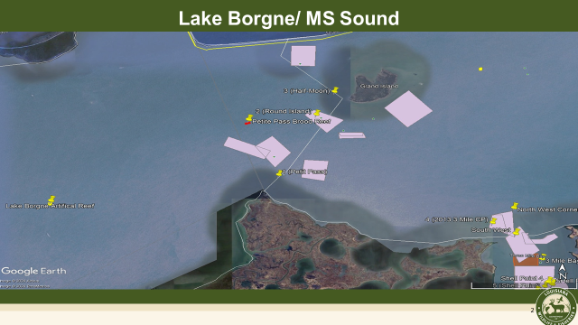

Headed to the Three Mile Bay area. We looked at 2013 Three Mile Bay CP, Shell Point, and West Karako.

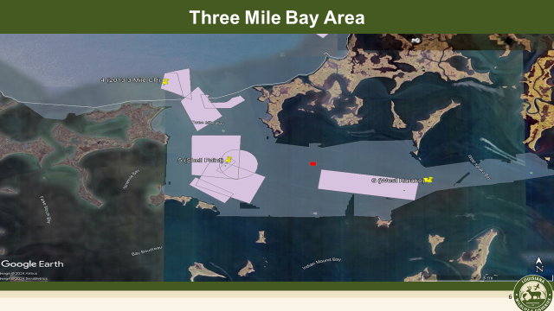

Square meter sampling will be available by the next meeting

There are two different monitoring operations for brood reefs at the Grand Isle hatchery, have contractors monitoring the deployments of how they grow over 18 months, NERDA money broad check of all brood reefs general overview of the health of each brood reef

A-2- The task force considered funding for the Oyster Day on the Bay breakfast

Jakov Jurisic motioned to approve funding up to $1000 to reimburse for the meal for the Oyster Day on the Bay, 2nd by Al Sunseri. Motion carries.

1. The task force discussed the possibility of opening public areas surrounding Marsh Island

Steve Voisin asked that LDH and LDWF consider areas surrounding Marsh Island to open for a special season

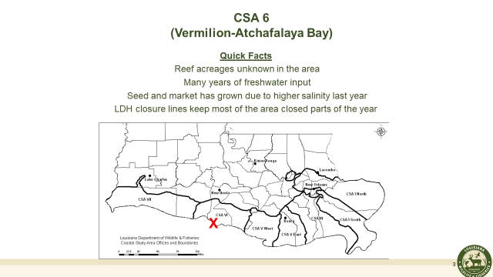

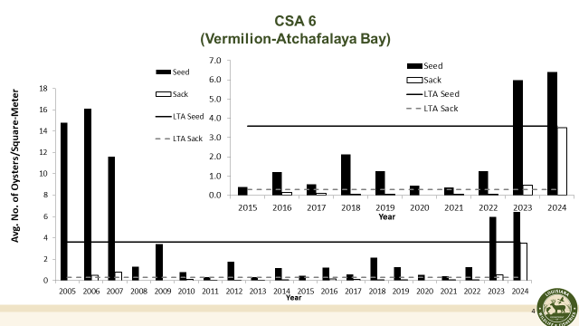

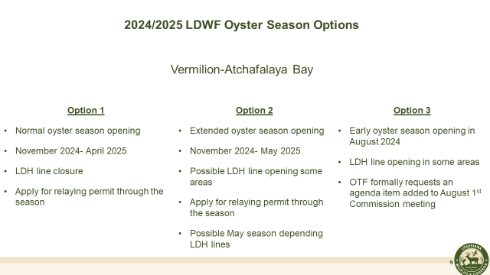

Al Sunseri motioned to choose option 3, which would see an early oyster season opening in August 2024 for Vermillion- Atchafalaya Bay, LDH line openings in some areas; season to open **for bedding only**, 2nd by Brad Robin. Motion carries.

Brad Robin motioned to petition the LDWF Commission to add an item to the August agenda to consider a special season opening in Vermillion- Atchafalaya Bay, 2nd by Willie Daisy. Motion carries.

1. Anna Koehl provided an update on the 2025 Washington, D.C. oyster industry event; provided some cost estimates for the 2025 Let the World Be Your Oyster Event

**Event name:** Let the World Be Your Oyster

**Purpose:** To highlight the strength and economic vitality of Louisiana’s oyster industry, celebrating the people who drive it, while informing and educating key stakeholders about current industry trends and challenges. Additionally, to highlight the industry’s proactive efforts and commitment to work with the state on smart and effective coastal restoration plans that ensure the long-term sustainability and resilience of Louisiana’s oyster industry.

**Date/Time:** Wednesday, January 22, 2025, from 6:00 – 8:00 p.m.

*Important note: There are two other events in competition on Wednesday evening during Washington Mardi Gras:*

* *The French Embassy: By invitation only, the Ambassador of France hosts a cocktail reception at his home celebrating Washington Mardi Gras. Invitees include members of the Louisiana Congressional Delegation. The event is popular and well attended and starts at 5:30.*
* *Chenier Energy: Chenier Energy hosts a big event (live band, food, etc.) drawing around 800 attendees from 7 – 10 p.m. Last year it was held at the National Portrait Gallery. (Have spoken with Jonathan Willems who produces both Louisiana Alive and Chenier Energy event)*

**Recommended schedule of events:**

* + 6:00 – 6:30 p.m.: Arrival and welcome drinks
  + 6:30 – 7:00 p.m.: Light appetizers and 3-4 featured Louisiana chefs + oyster dish; guests mingle
  + 7:00 – 7:30 p.m.: Guests continue to mingle and prepared remarks
  + 7:30 – 8:00 p.m.: Continued mingling

**Targeted Stakeholders:**

* Louisiana state representatives and senators
* Regulatory agencies
  + FDA
  + NOAA
  + EPA
  + USDA
* Louisiana commercial fisheries and partners (Joint Task Forces, LSPMB, LRA, LODGA, etc.)
* Media (Gulf Seafood News)
* Chefs

*Target guest count: 200*

**Potential Sponsors**

* Louisiana Oyster Dealers & Growers Association – maintain sponsorships and venue
* Louisiana Seafood Promotion and Marketing Board
* Acme Oyster House
* Shell
* Couvillion
* Louisiana brand product (i.e. Tabasco, Zatarains, Crystal, Sazerac Company, etc.)
* Louisiana Oyster Dealers & Growers Association – maintain sponsorships
* Gulf Seafood Institute

*Sponsors will get credit in collateral and media materials (i.e. press release, welcome signage, social media, designated # of wristbands, etc.)*

**Venue Recommendations:**

* Dauphine’s – great party space (closer than Acadiana)

1100 15th St NW

*(Located in the heart of Washington, D.C. just blocks from the White House and a 10 minute walk to the National Mall)*

* + F&B minimum: $20,000; estimated minimum $28,380 (incl. tax, service charge, admin fee and surcharge
  + Longshot Hospitality Group and Neil Boddenheimer (New Orleans)
* The Old Ebbitt Grill: [www.ebbitt.com](http://www.ebbitt.com)
  + F&B minimum: $25,000; room fee: $2,500 (taxes and other fees not included)
  + COCKTAIL RECEPTION (2 Hour Service): Choose 5: $45 per guest ($9,000) Choose 8: $65 per guest Choose 10: $81 per guest
* Ophelia's Fish House and Oyster Bar: [www.opheliasdc.com/gallery/ophelias/](http://www.opheliasdc.com/gallery/ophelias/)
  + Cocktail reception up to 100 guests
  + ~10 minute drive
* Hawk n Dove: hawkndovebardc.com
  + ~10 minute walk from The Capitol
* The Salt Line: thesaltline.com
  + Longshot Hospitality Group
  + Along the Anacostia River
  + ~10 minute drive

*Note Acadiana cost approximately $36,500.*

**Budget Considerations:**

* Venue
* Oysters
  + Plus shipping costs
* Security
* Photographer
* Invitations
* Design (Refresh past invitation design)
* Printing
* Postage
* Envelopes
* Wristbands
* Signage (Welcome poster/banner, sponsor display signage, table signage)
* Entertainment

Al Sunseri suggested bringing in food writers and getting some articles out of the event in local or national broadcast companies, morning shows, and maybe some things after on the news both in Washington, D.C. and locally

1. Lourdes Keiffer provided a presentation on a marketing proposal from WWLTV

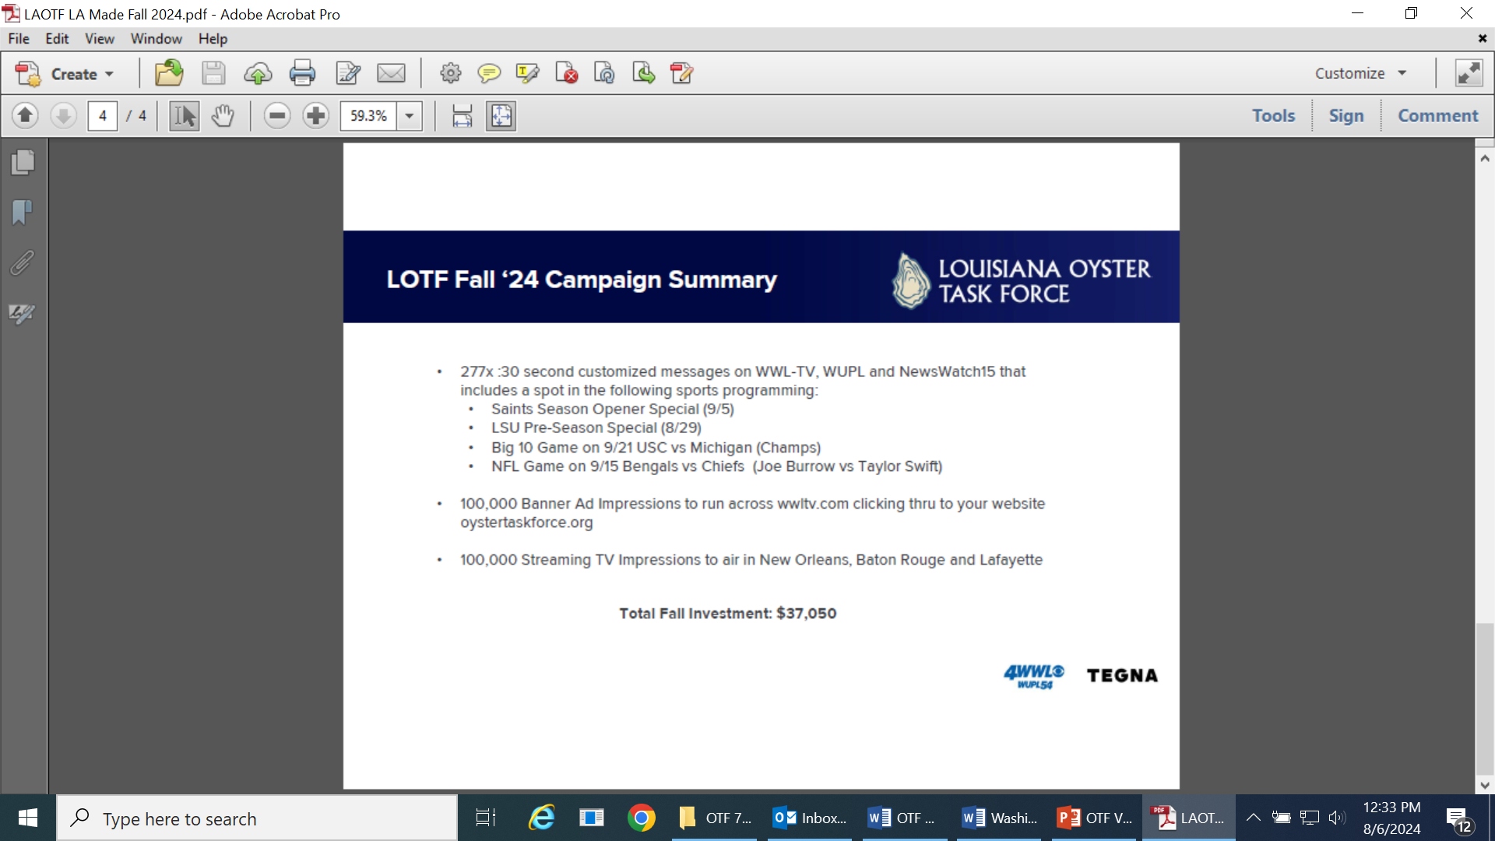

1. John Bennett provided a presentation on a marketing opportunity with Fox 8

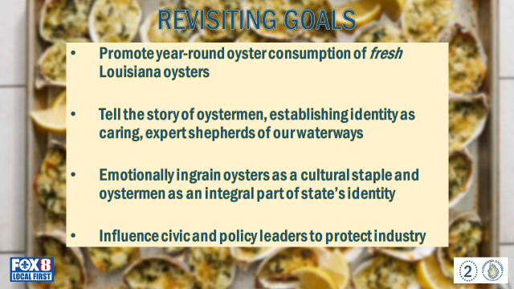

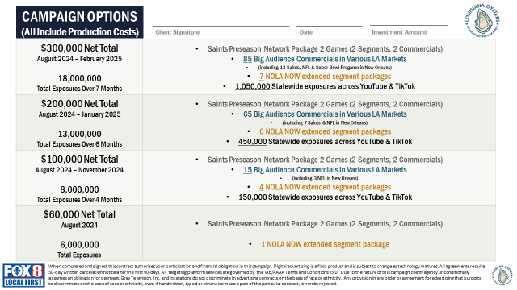

1. Kelly Dimarco with Plaquemines Parish Economic Development led discussion on 2025 Super Bowl events and the possibility of oyster industry participation

The task force discussed the ability to participate in a VIP event at the Lakefront Airport and/or the Governor’s Mansion event, both events are in coordination with the 2025 Super Bowl which will be held in New Orleans

Brad Robin motioned for the task force to participate and request the official invitation to participate in the 2025 Super Bowl events with FBO, 2nd Jakov Jurisic. Motion carries.

1. Earl Melancon provided a presentation on the final report on the 2021-2023 AOC Grant Program

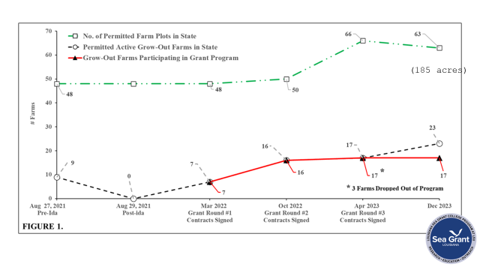

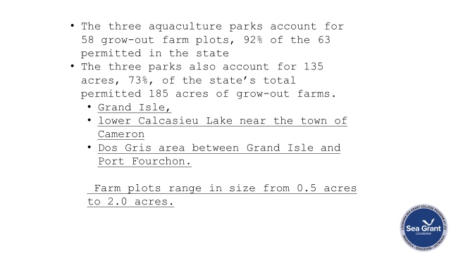

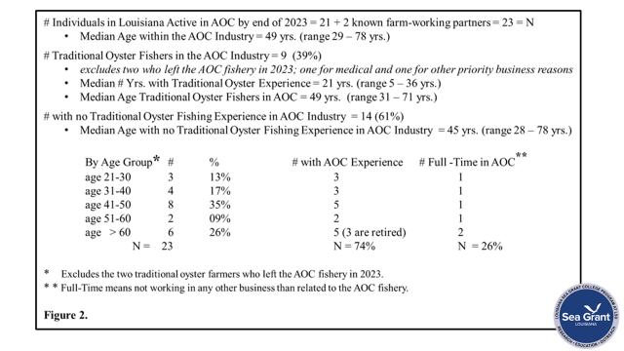

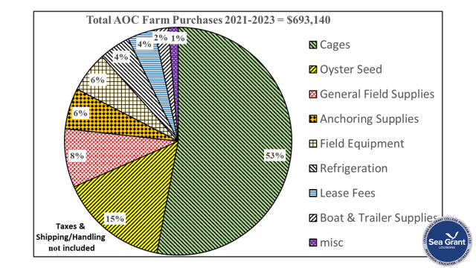

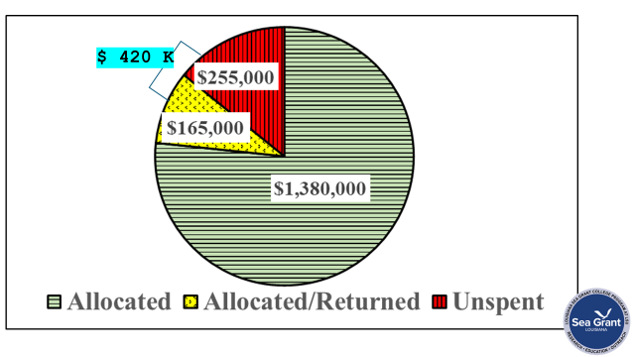

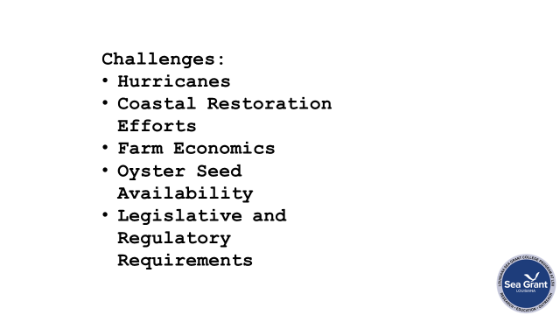

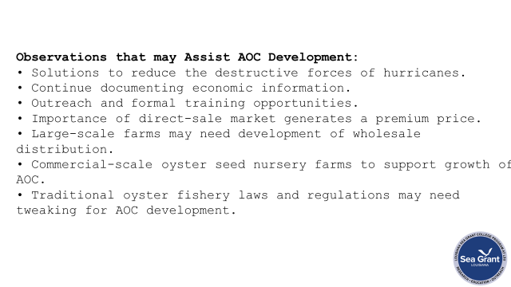

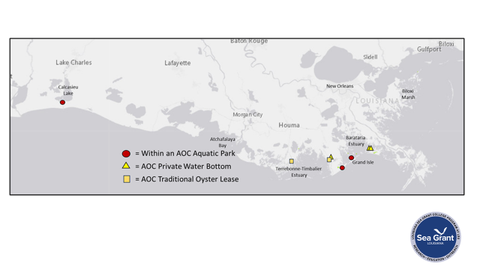

**VII.** Public Comment

**VIII.** The next meeting was set for Monday, August 19, 2024 for 10:00am at the New Orleans Lakefront Airport; ~~Marketing meeting 9am~~

**IX.** Brad Robin motioned to adjourn the meeting, 2nd by Willie Daisy. Motion carries.